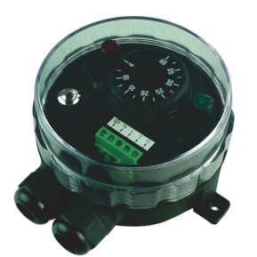

**Type YF63NC and YF65NC**

**Adjustable manual reset electronic room limiters**

Applications: Equipment requesting a very strong resistance to water ingress.

Housing: Protection class IP 66 upon EN 60529. Body in black PA66, fiber glass reinforced. Mechanical impact resistance: IK10. High UV resistance.

Set point adjustment ranges: -35-35°C, 0-10°C, 4-40°C.

Contact: SPST. 16A (2.6), 250VAC.

Maximum ambient temperature: 60°C (140°F).